2023 comparisons plot photos
Plot S11 (Enhancement) July 2013 Plot S11 IMG_2182
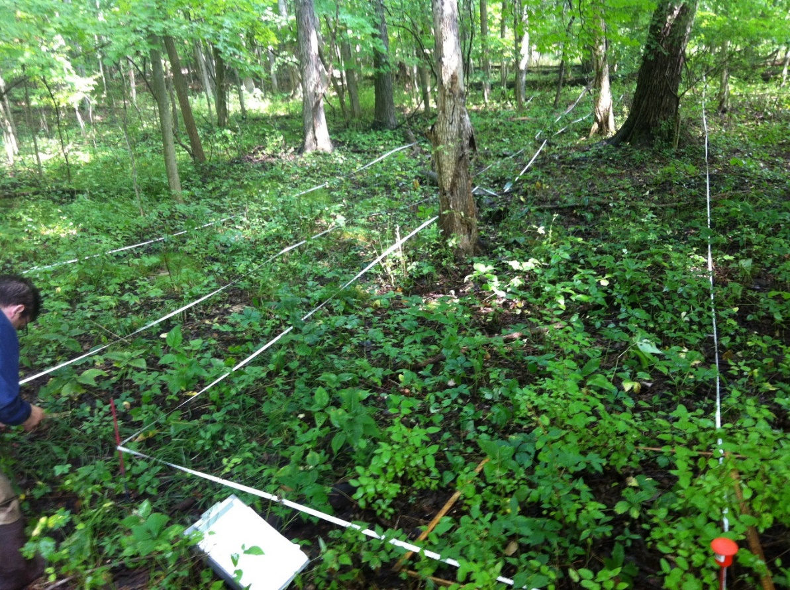

July 2022. Plot S11, SW corner. IMG_4171
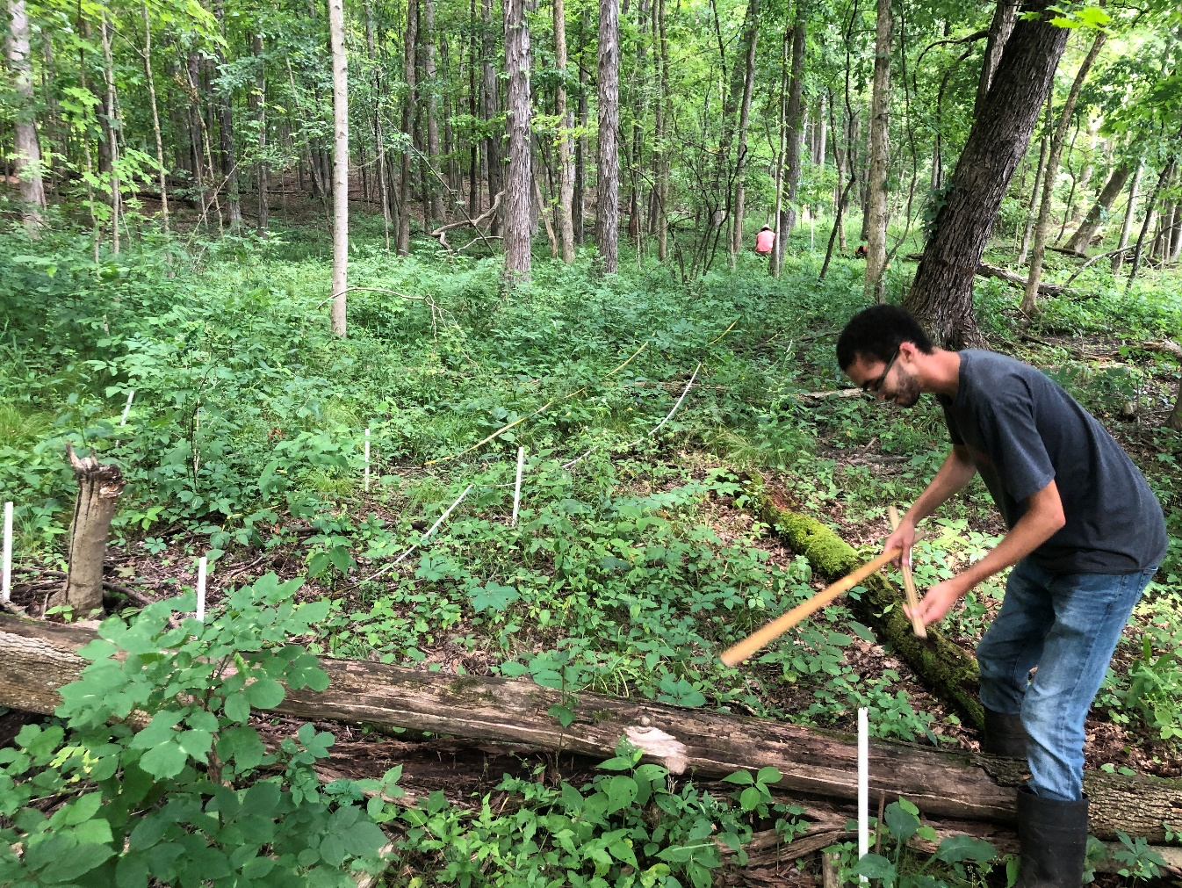
Plot S7 August 2014 (Enhancement): plot S7 – IMG_4123.jpg
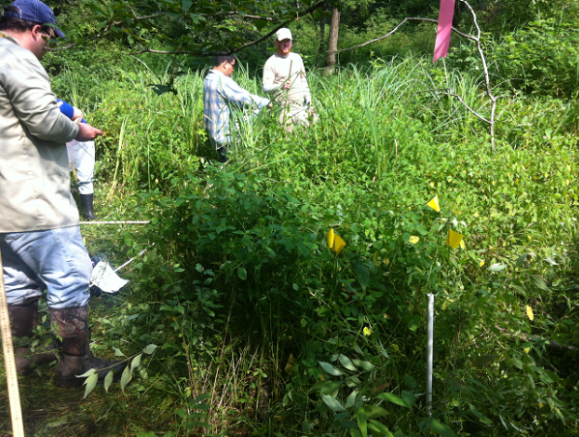

July 2023 Plot S7 SE. IMG_6867. Lake Sedge has greatly increased. Silky dogwood in upper right is steady
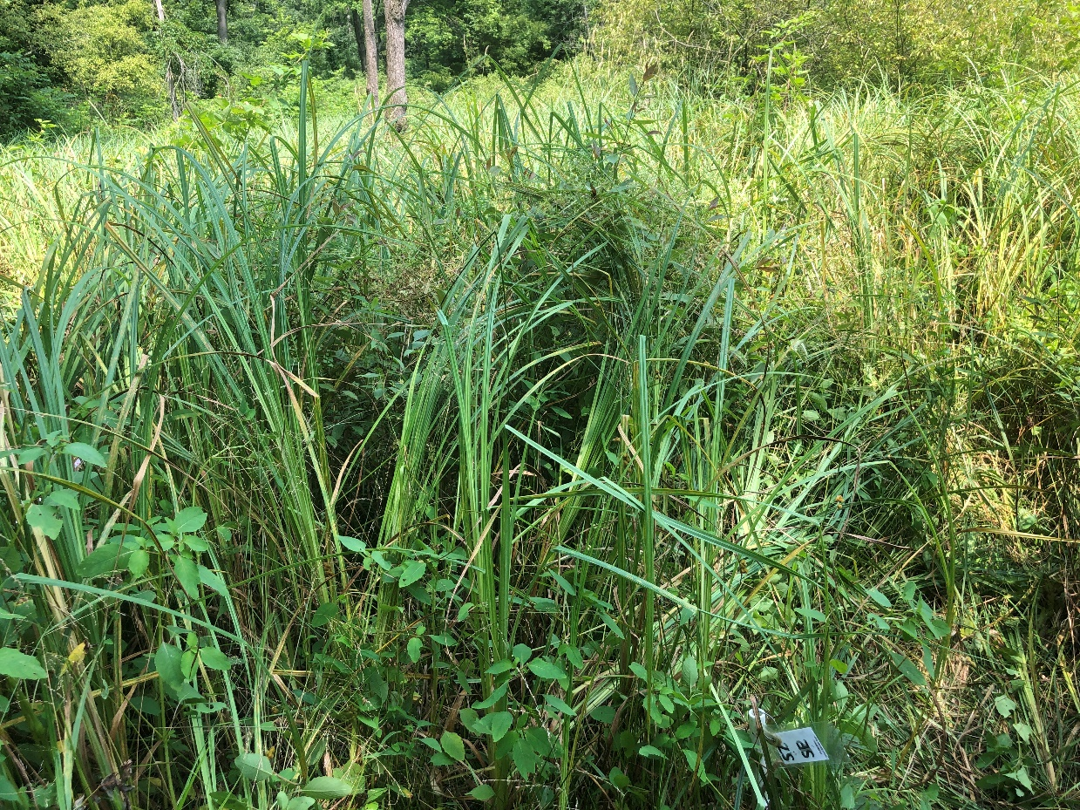
Plot S1 May 2015 (Enhancement): Plot s1 from north photo dsc_3952
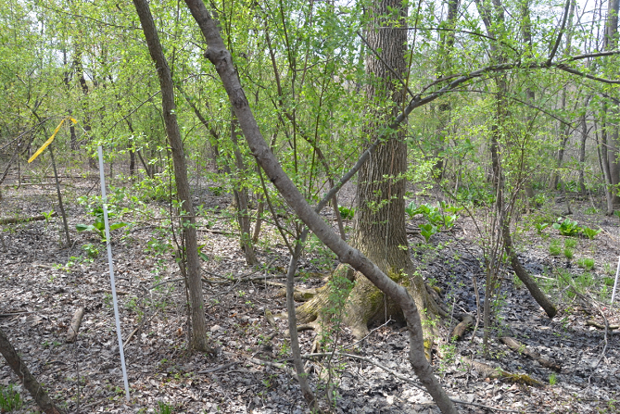

May 2023 Plot S1 NE. IMG_5404. The large central tree from 2015 has fallen, as has the sapling left of it (see trunks of both in the slightly different angle from 2023). Enormous increase in Lake Sedge, and reduction in crabapple
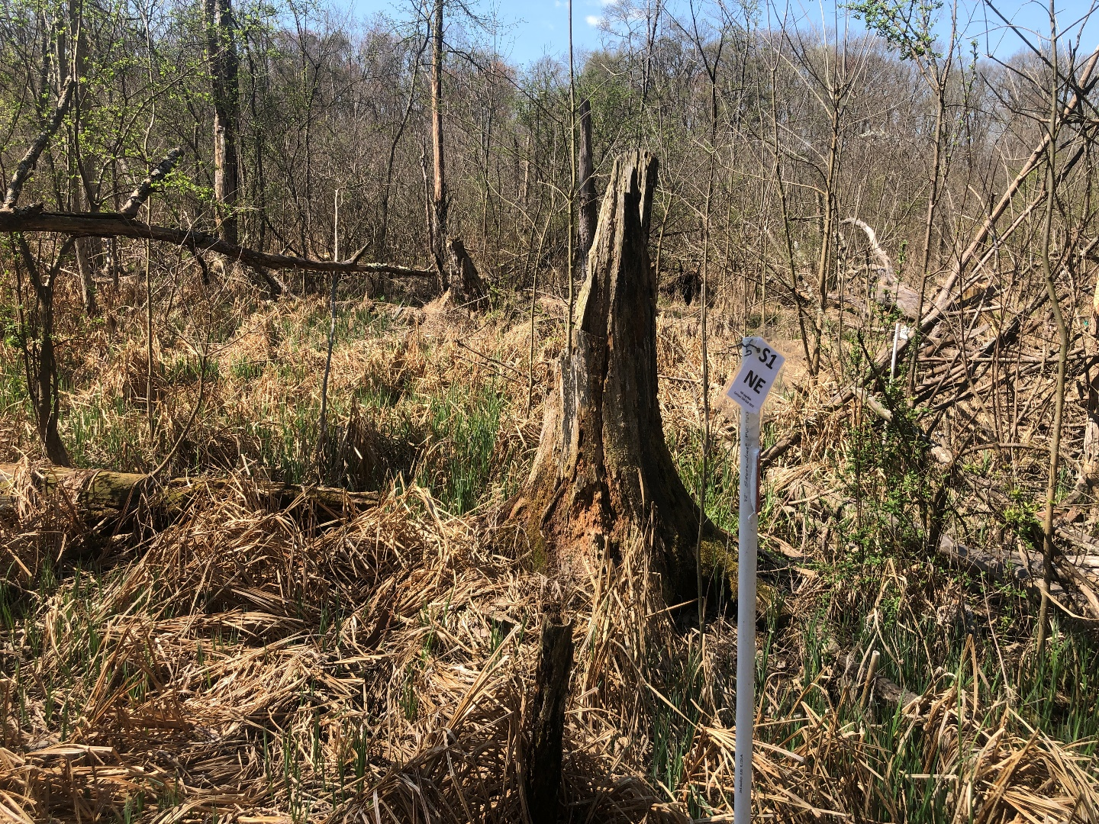
Plot S4 July 2013 (Enhancement). Plot S4 img2113 July 2023 Plot S4 SE. IMG_6737.
Note strong increase in herbaceous vegetation.
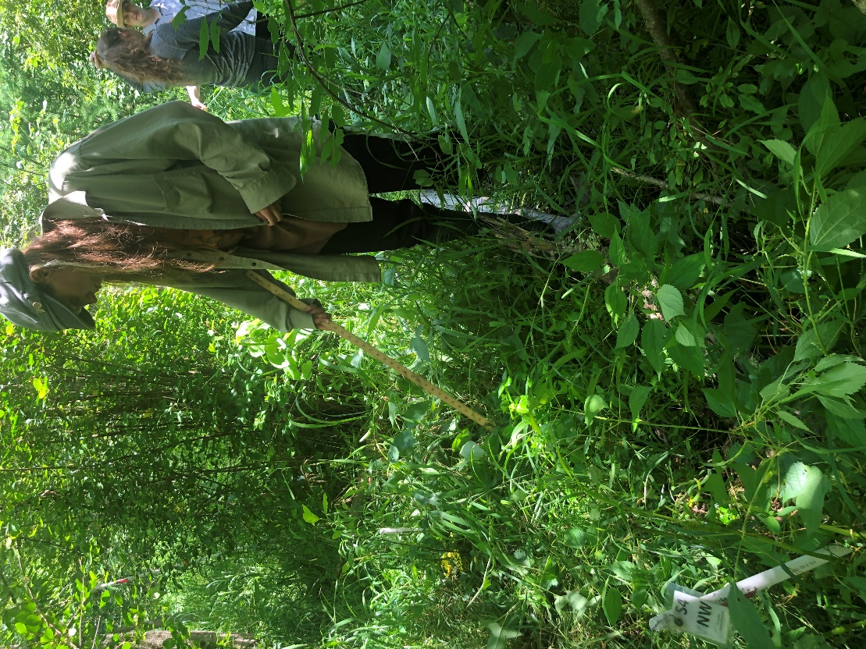
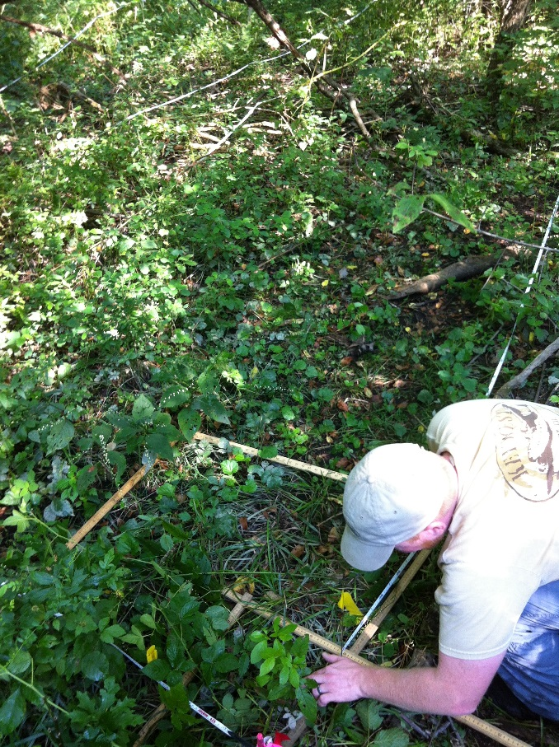

Plot S2 July 2014 (Edge) Plot S2 from NE. IMG_2100.
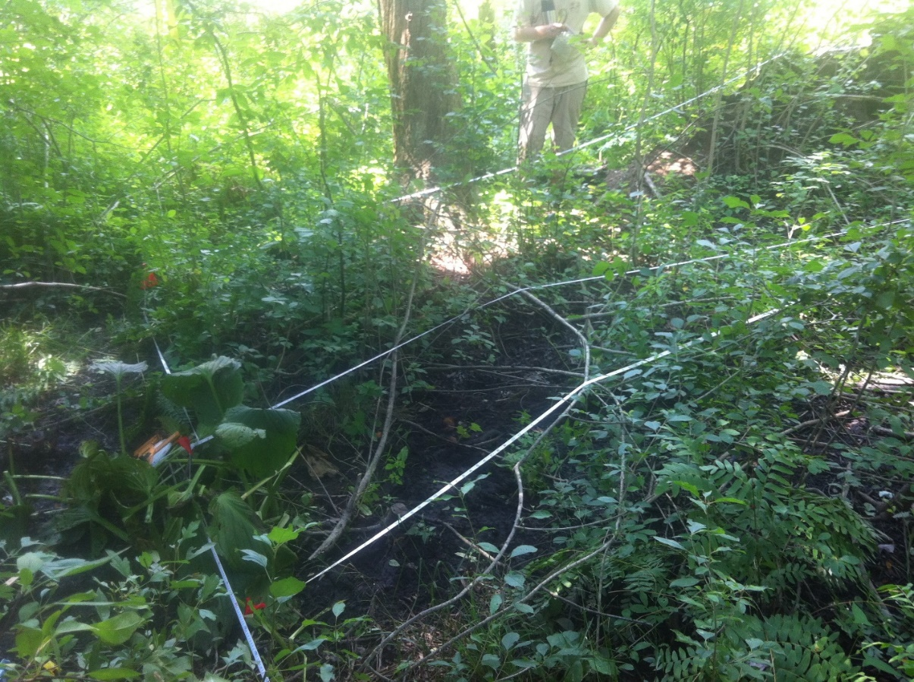

July 2023 Plot S2 from NE corner (note meter tape in center left. Which is in the same location and orientation as in the earlier photo). The hummock in 2014 has been obscured by the strong increase in herbaceous and woody cover. Royal fern patch perseveres. A very large red maple just out of view to the right of these photos fell in 2020.
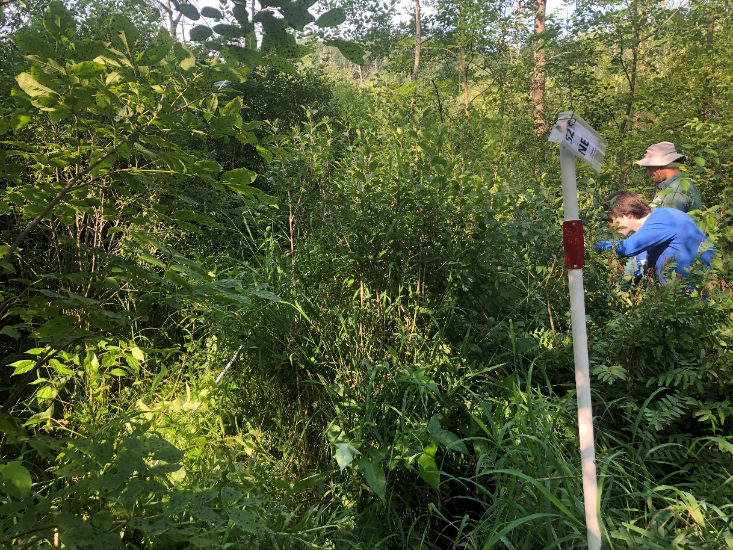
Plot S9 May 2015 (Edge). Plot S9 from NW DSC_4050
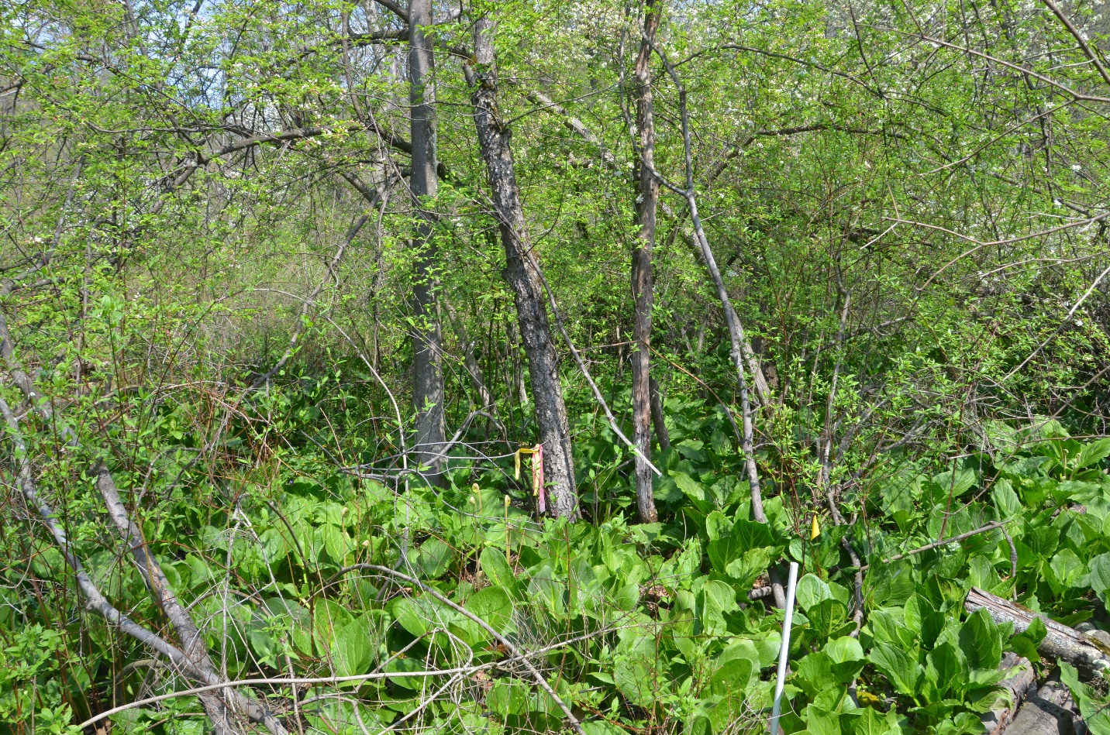

May 2023 Plot S9 NW corner. Photo location differs slightly in the two years. Skunk cabbage perseveres, Lake Sedge has arrived, and woody vegetation has matured (including arrival of Quaking Aspen).
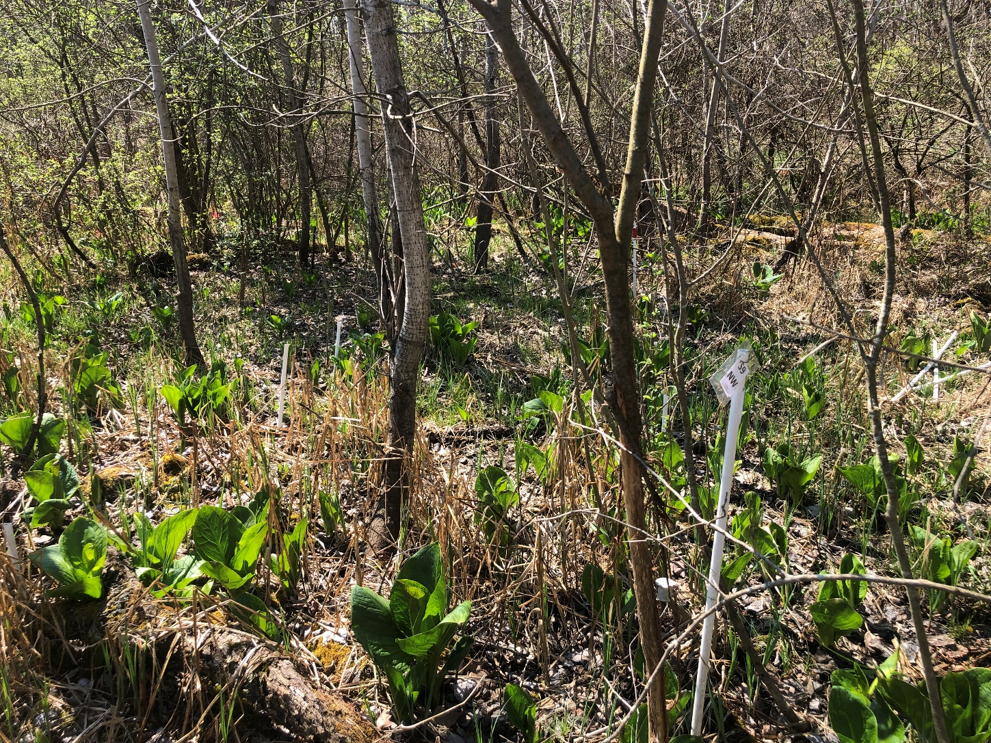
Plot 10 May 2015 (Edge): View from Plot S10 SW DSC_4029. Looking NE
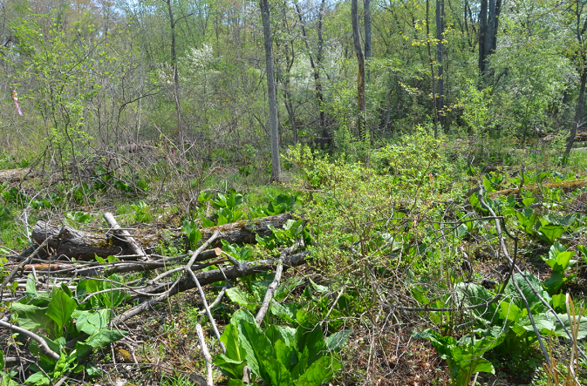

May 2023. Plot S10 SW looking North. Note increase in Lake Sedge, maintenance of Skunk Cabbage
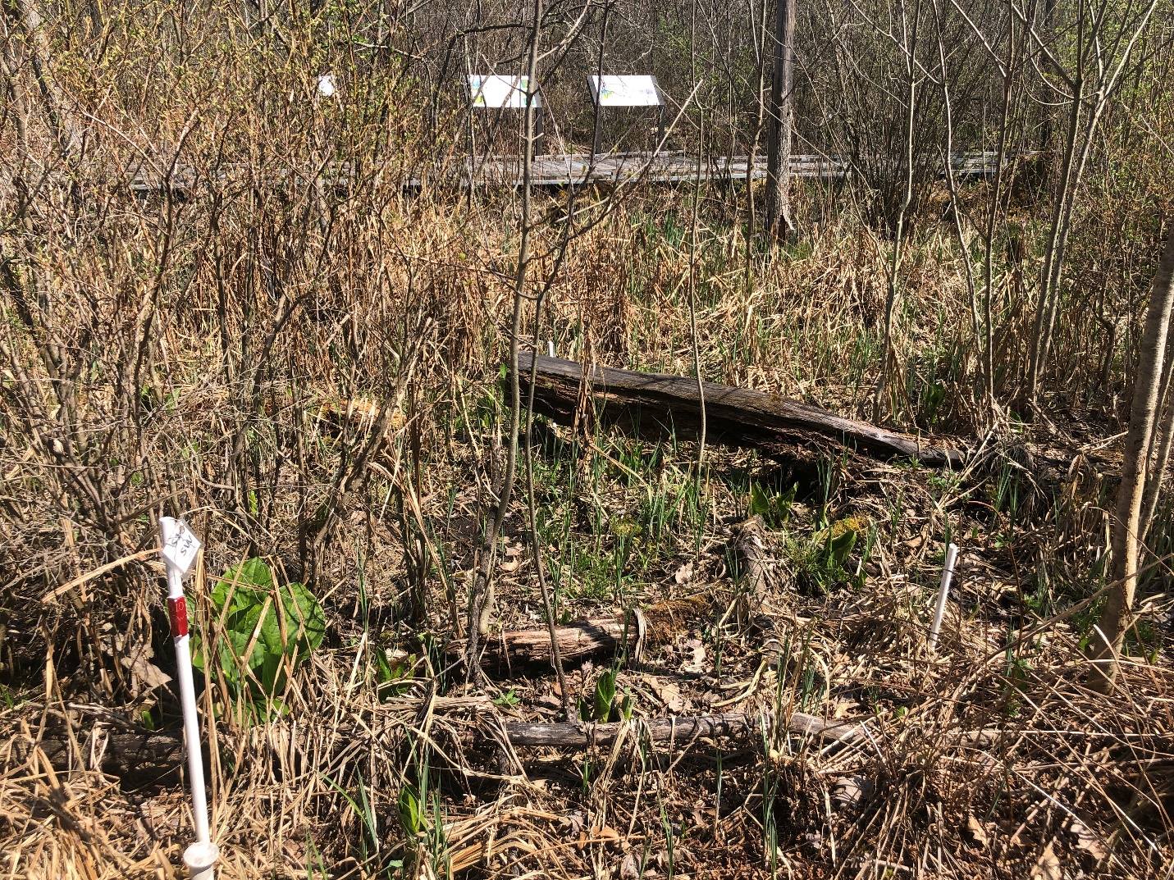

Plot S6 May 2016 (Edge). Plot S6 SW DSC_5209
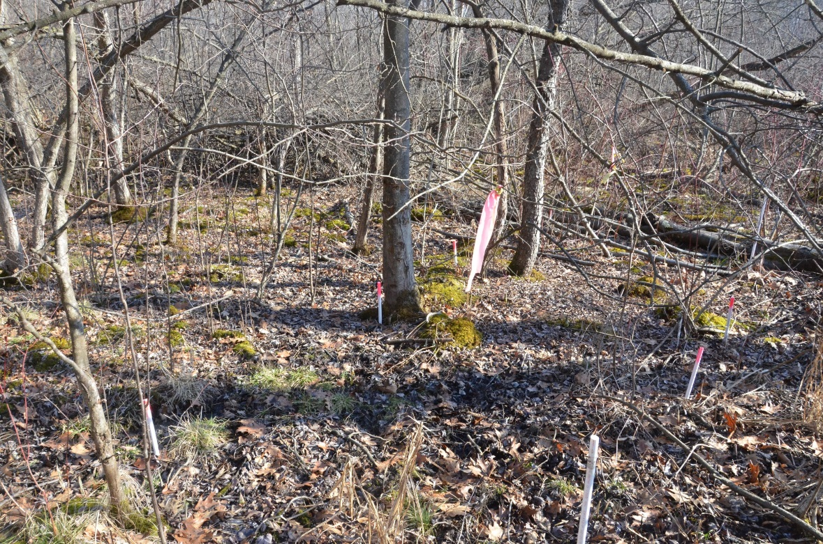

Plot S6 May 2023. A prominent tree has fallen. Woody vegetation has maintained, skunk cabbage maintains.
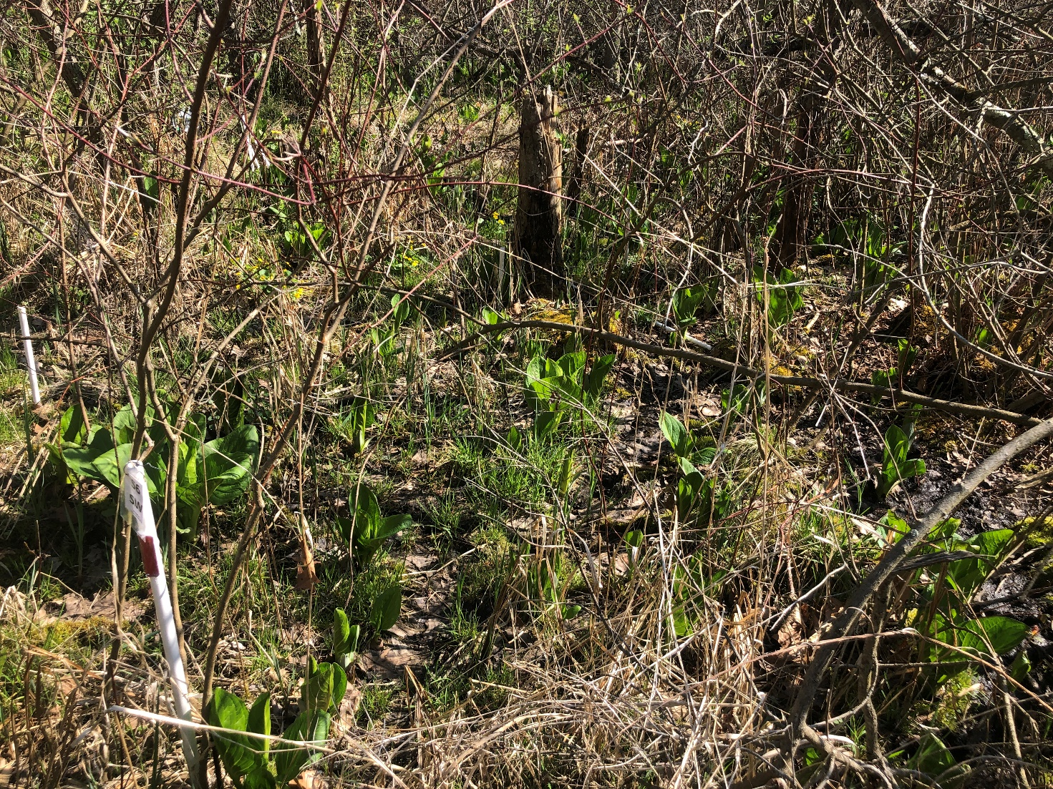

Plot S8 August 2014 (Core): S8 NE Corner to SW Corner
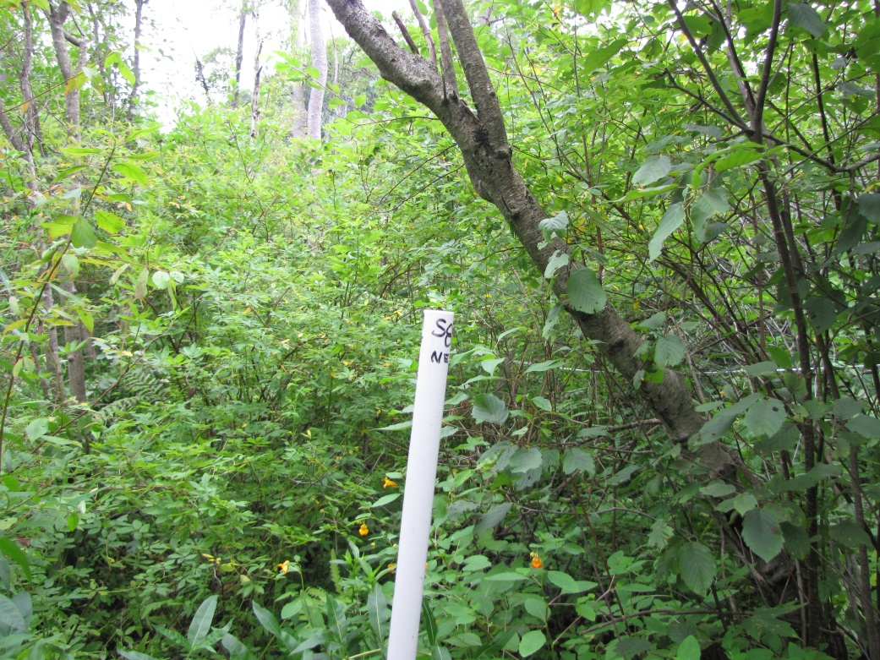

July 2023. Plot S8 NE, view to SW. The thick woody vegetation remains in place, and may be more dense (note impatiens and more sunlight penetration in earlier photo)
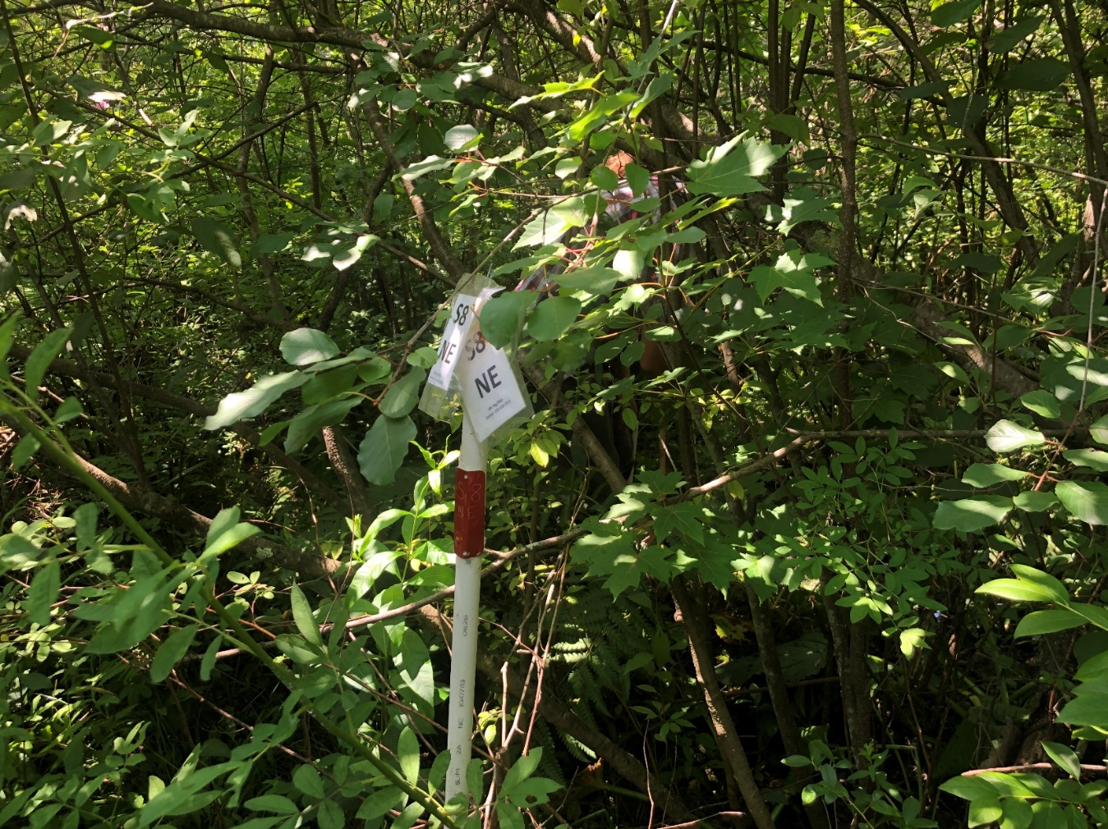
Plot S3 July 2015 (Core): Plot S3 NE. IMG_5442
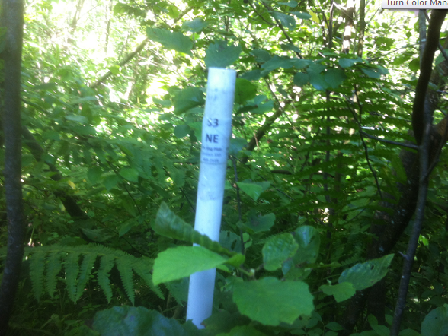

July 2023 Plot S3 NE looking SW. IMG_6785. The impenetrable vegetation of 2015 is just as impenetrable in 2023, Cinnamon Fern is still prominent.
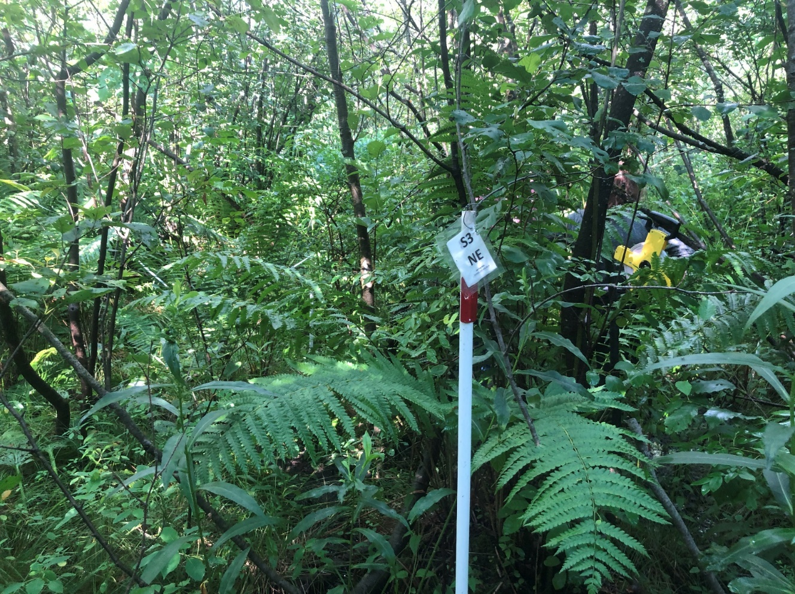
Plot S5 May 2015 (Core): Plot S5. DSC_3976
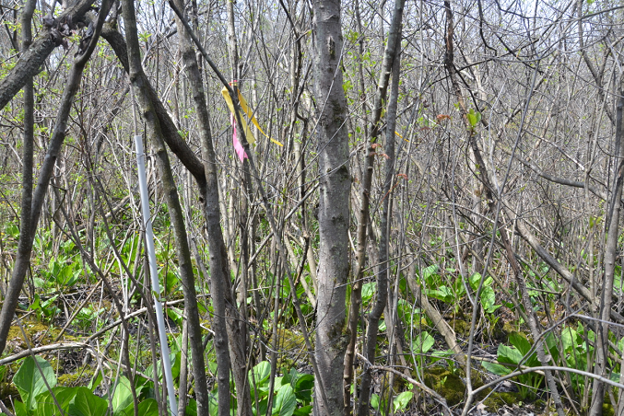

May 2023 Plot S5 NE. IMG_5916. A large shrub has fallen into the plot, but the vegetation structure is consistent over time, and skunk cabbage remains abundant.
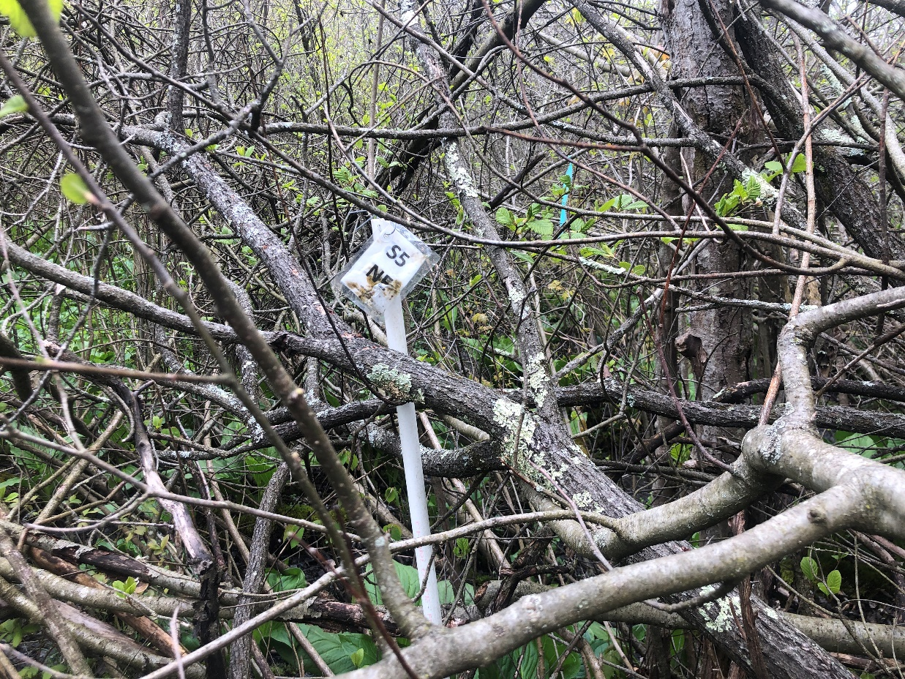
Plots added later than 2013:
Plot S12 July 2020 (Enhancement). Plot S12 from north along aisle (this plot was not constructed until 2020)
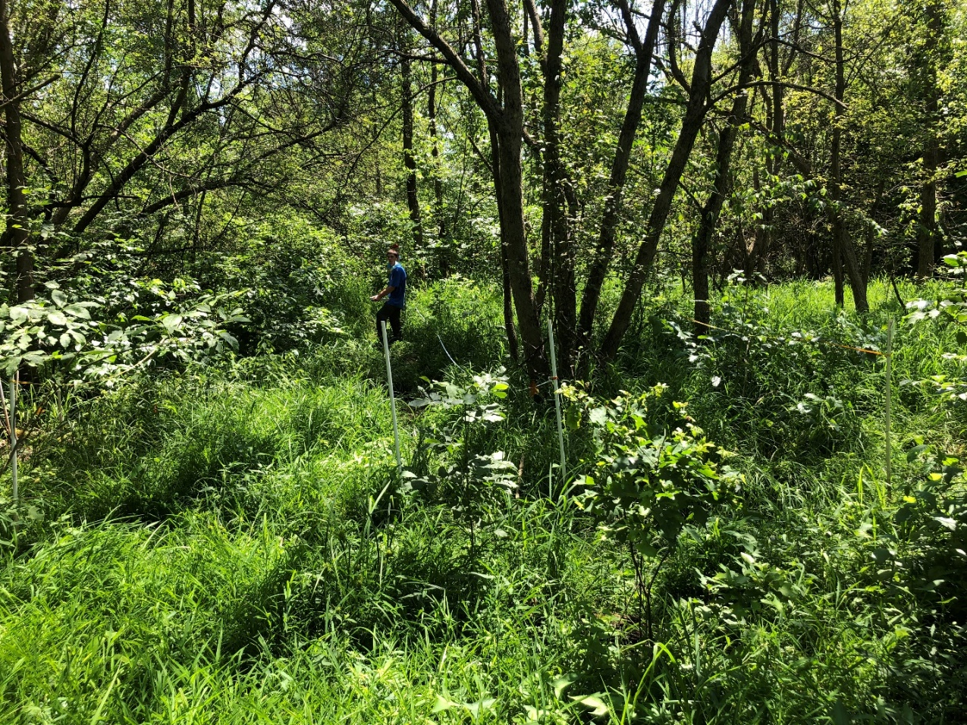\

July 2023. Plot S12 from North along aisle.

