Appendix H. Repeat photos along the boardwalk.
As required, a boardwalk was installed at the Tamarack Bog, to encourage public access. This was installed by Bath Parks employees in 2015-2016, following the guidance provided in the controlling documents. In 2016-17 we established several repeat photo stations along the boardwalk. The figure below shows an example of a photo station, and a map of the location and view of each of these stations.
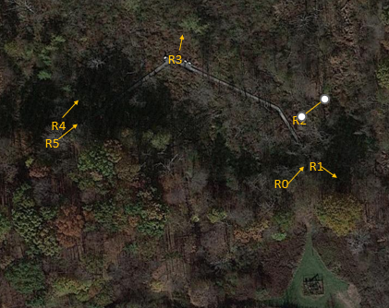
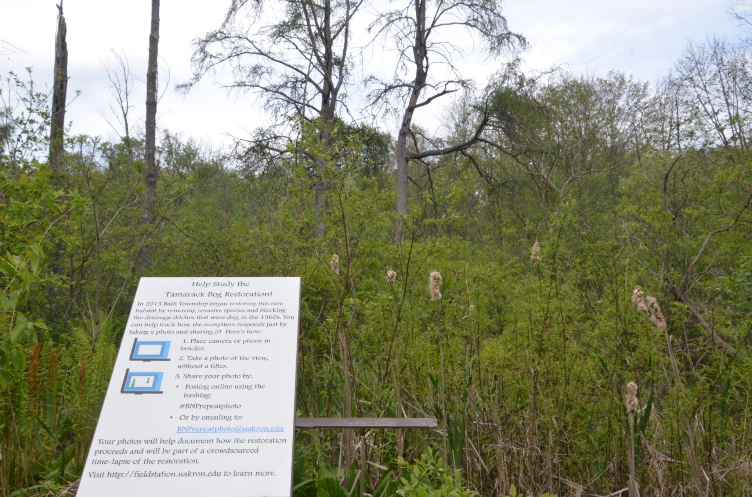

Figure 1. Left. Repeat photo station (R3). Camera or phone can be placed on the horizontal bracket for consistent placement and orientation. SIgnage guides the public on how to take a photo and to share (via email) with the tamarack bog monitoring team. Right Map of repeat photo stations. Arrows indicate direction of the view The boardwalk is the gray linear feature that is partially obscured by trees. R1-4 have permanent brackets to guide photographers. R0 and R5 do not have brackets, but are taken from a known location at the beginning and end of the boardwalk, aimed along the boardwalk. The parking area and oil/gas well is visible in the lower right.

We have taken photographs at these stations at intervals since then (over 460 photos to date), and members of the public have shared over 38 photos as well.
Below are some useful photos from these stations, with brief commentary. In most cases we provide the earliest available photo and the most recent, at several times of year.
Site R0. Eastern End of the Boardwalk. The Boardwalk route was flagged in 2015 (see first photo), and installed in 2016. First row shows Early Spring views, showing no major changes in the vegetation at this site as of 2023. Second row shows a View in Fall from 2016-2023, again showing no major changes. The third row shows Early Summer views. There is a notable increase in woody vegetation on the right, mostly Green Ash. Herbaceous cover left of the boardwalk has increased (mostly grasses such as Fowl Mannagrass, and various herbs including Jewelweed).
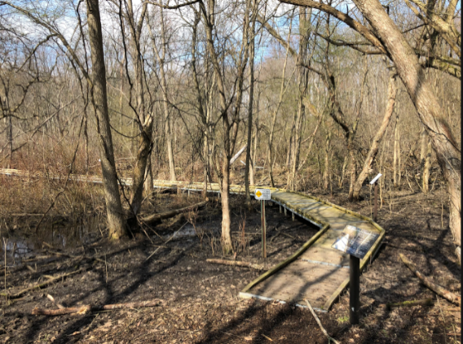
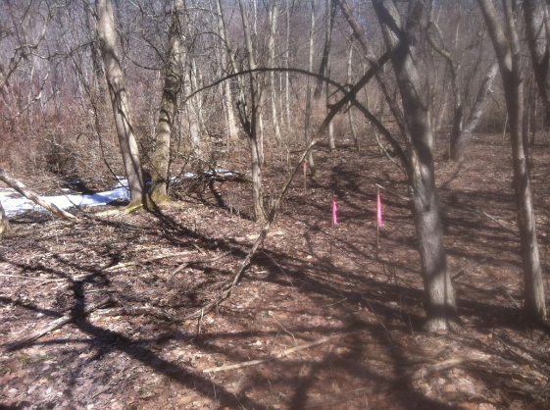
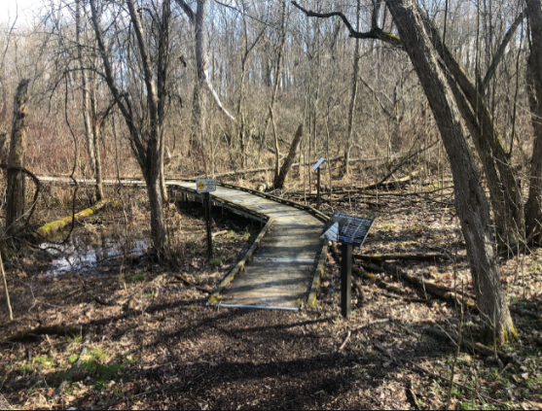
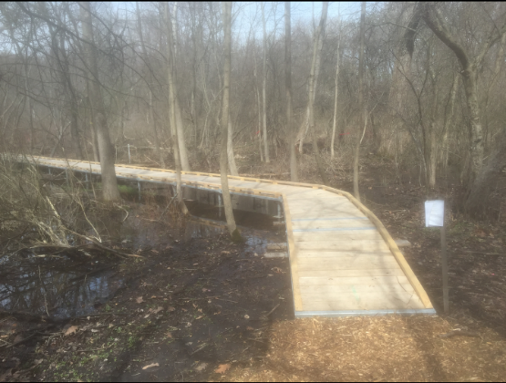
R0 March 24, 2015 R0 March 30, 2016 R0 April 14, 2019 R0 April 2, 2023

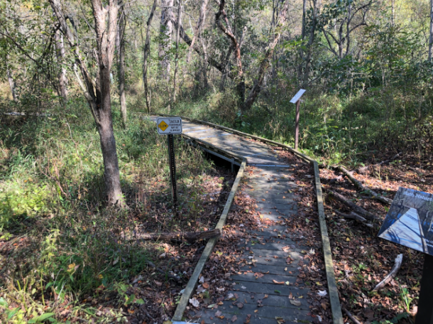
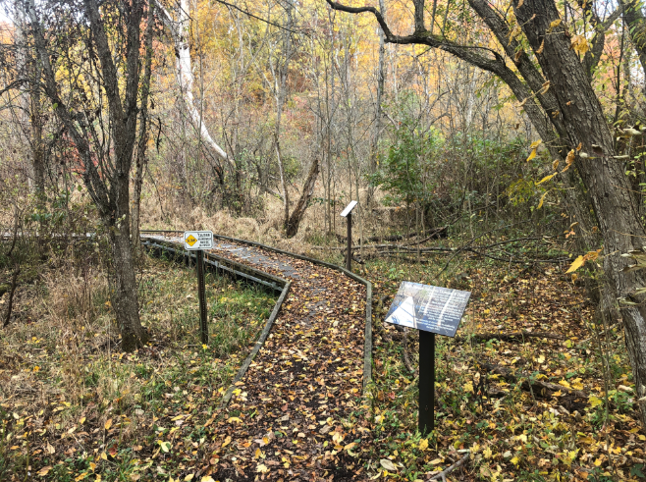
R0 November 25, 2016 R0 October 10, 2019 R0 October 25, 2023
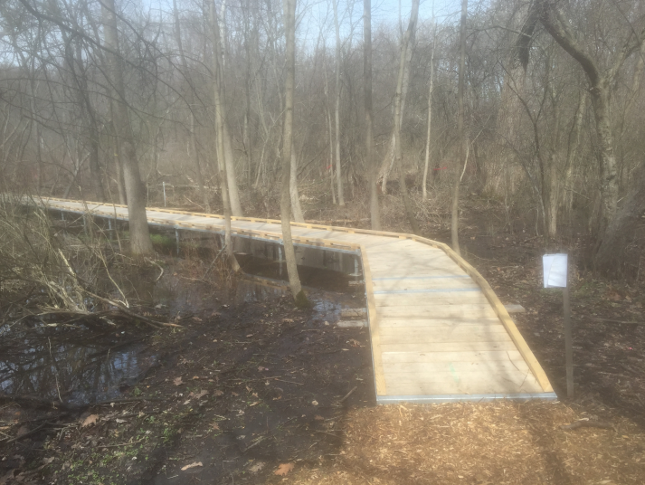
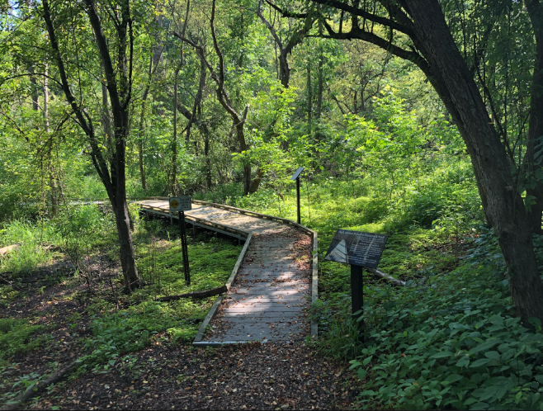
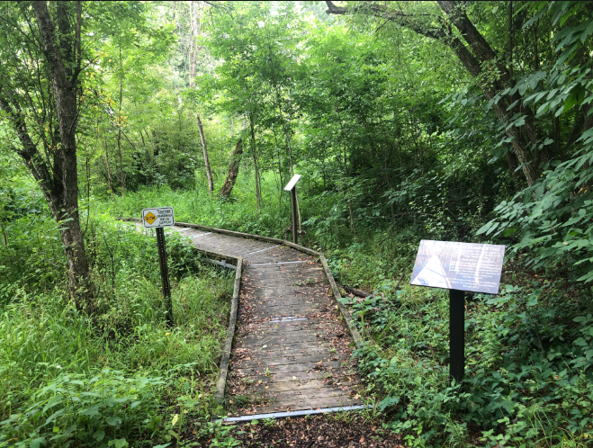
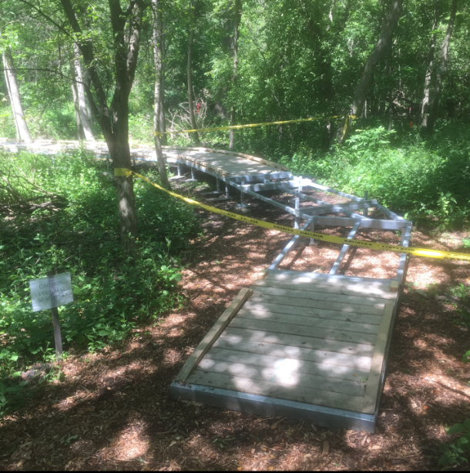
R0 June 21, 2016 R0 June 28, 2019 R0 July 16, 2023
Site R5. The Western End of the Boardwalk. First row shows early spring in 2019 and 2023, with an increase in silky dogwood cover on the left. The second row shows early summer installation in 2015, and a progression through 2023. WIngstem and other tall vegetation is on the near left, while the woody vegetation (silky dogwood and swamp rose) on the far left is increasing. Skunk cabbage is present in all years, although less visible in later years. Recovery from boardwalk placement (directly next to boardwalk is strong and consists of native species similar to those in undisturbed adjacent areas.
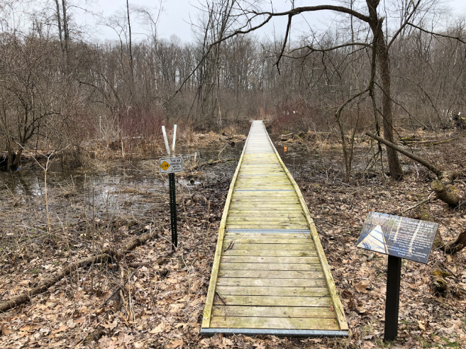
R5 April 4, 2019 April 2, 2023
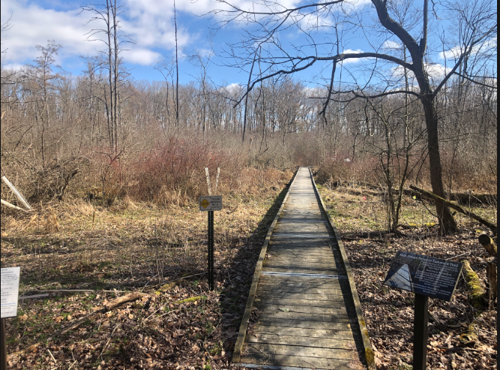

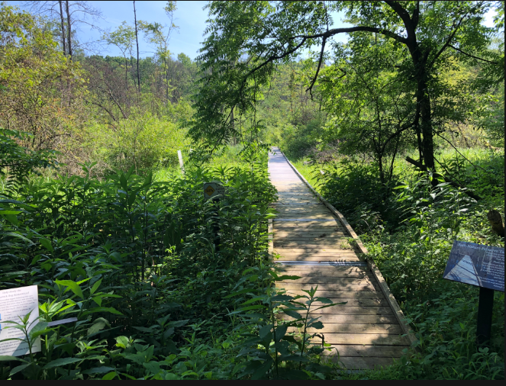
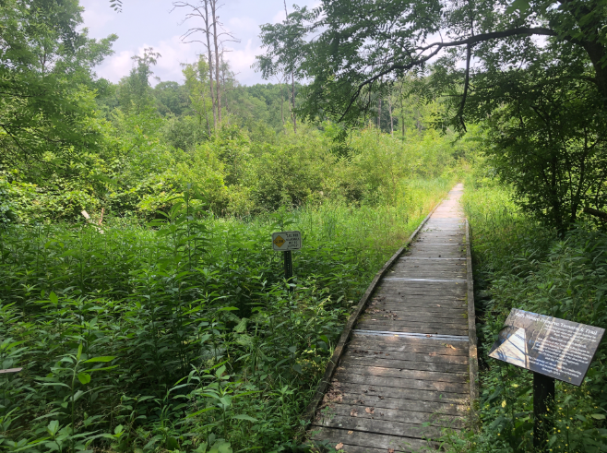
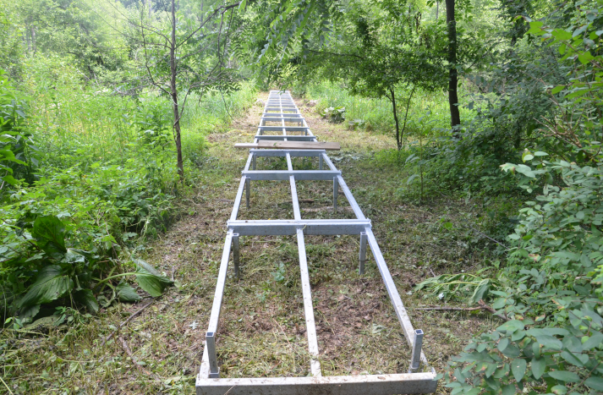
R5 June 24, 2015 R5 June 28, 2019 R5 July 15, 2023

Site R1. View upland from the edge of the wetland. First row shows Early Spring. with little notable change aside from an increase in woody stems and different timing of flooding and greening. The second row shows MId Summer, with a distinct increase in woody vegetation, especially Green Ash.
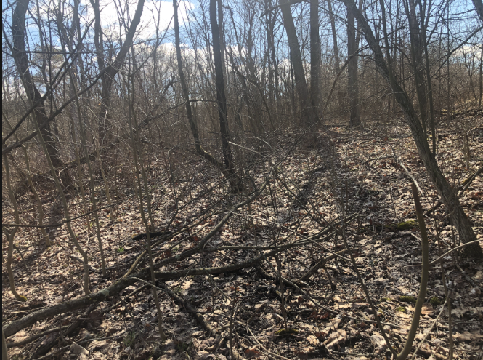
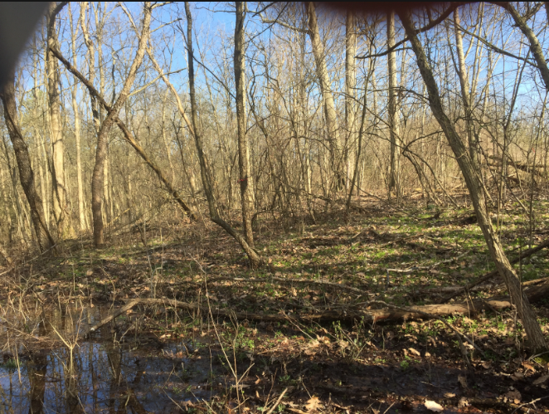
R1 April 5 2017 R1 April 2, 2023

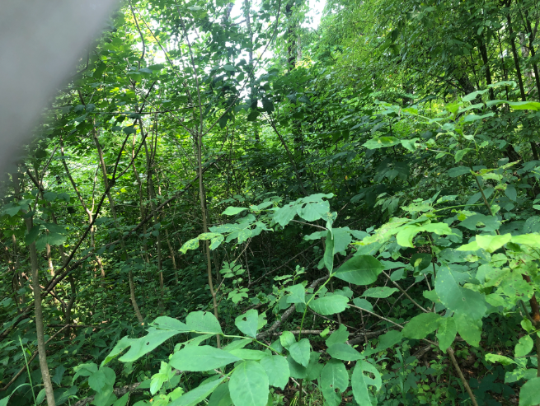
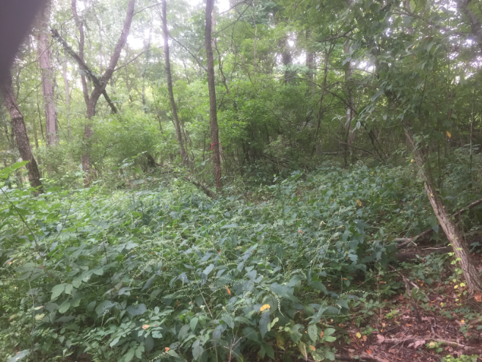
R1 Aug 10, 2017 Augst 2, 2023
Site R2. View to East. First row shows Early Spring. Periodic flooding at this time of year is common. Several trees have fallen (including the “leaner” in 2023), and the cover of woody and herbaceous vegetation has increased. Second row shows strong increases in woody and herbaceous vegetation.
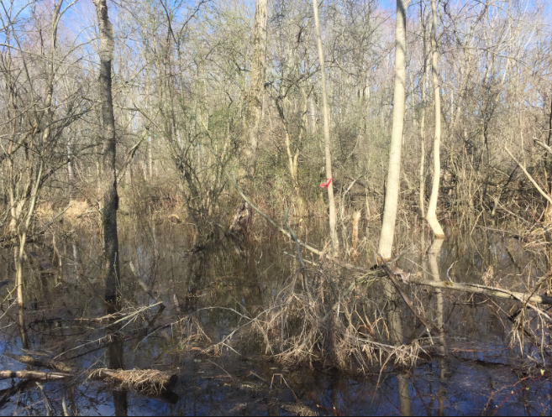
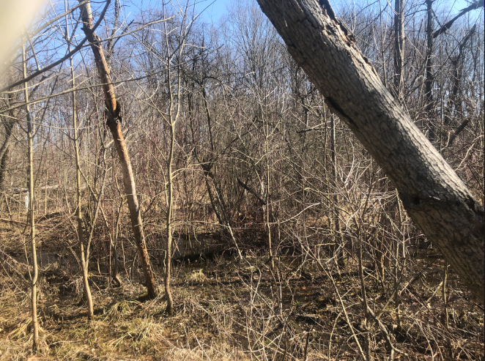
R2 April 5, 2017 R2 March 26, 2023

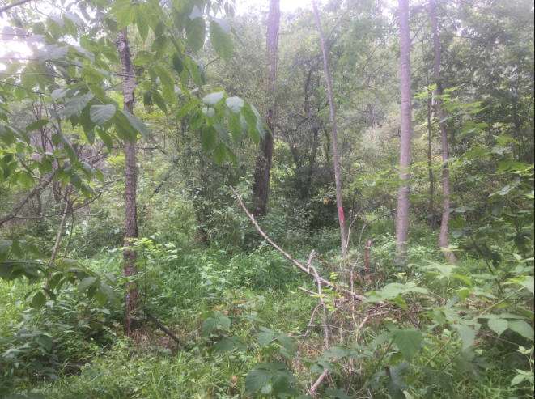
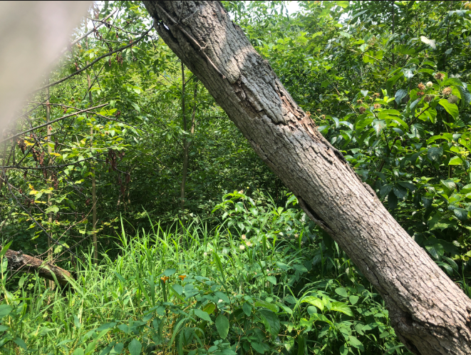
R2 Aug 10, 2017 Aug 2, 2023
Site R3. Core Bog and Tamaracks. First row shows Early Spring. Cattails have decreased, woody vegetation (mostly Blueberry, Silky Dogwood, and Alder) have increased. Two tall Tamarack trees are prominent in the middle distance. Second Row shows Mid Summer. Again, increased vegetative cover. Note that the increase in growth is enough to obscure the horizon.
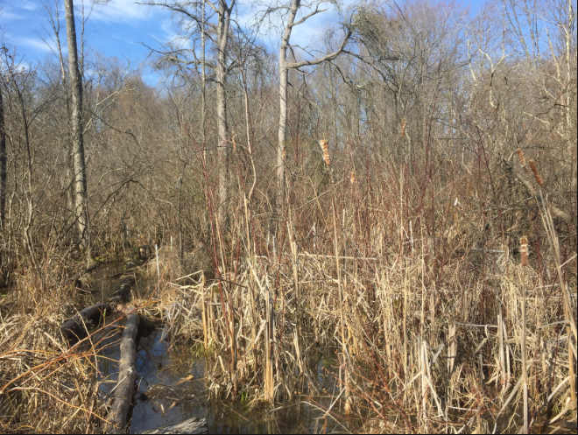
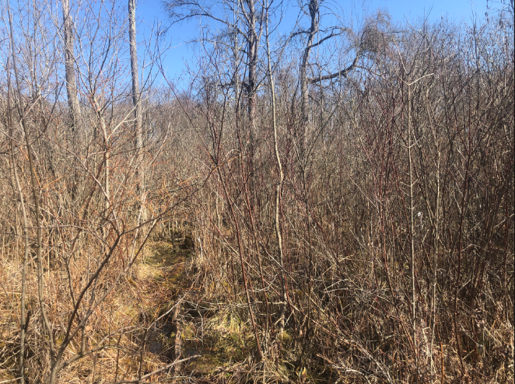
R3 April 5, 2017 R3 March 26, 2023

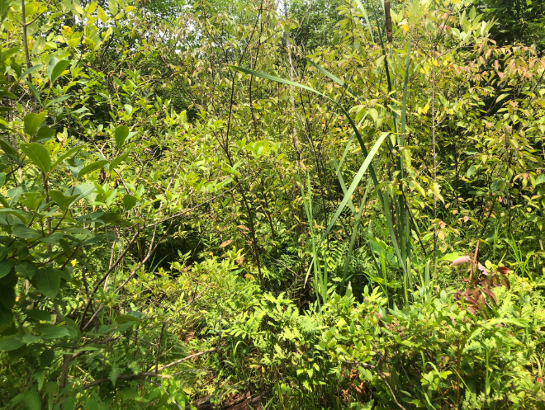
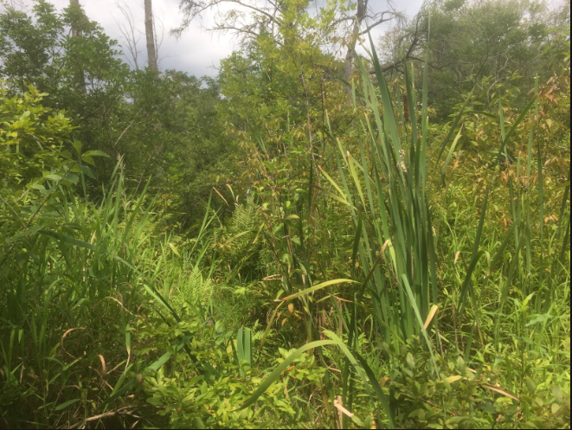
R3 August 10, 2017 R3 August 2, 2023
Site R4. View into wetland from edge. First row shows Early Spring, and an increase in silky dogwood on the right. White herbivore exclusion tubes for tplanted tamaracks are visible (several are askew because of a recently fallen shrub). Graminoids and herbs have increased (including Lake Sedge, Rice Cutgrass, and Tearthumb). Second row shows Mid Summer. Wingstem vegetation in the foreground obscures the rest of the view in both years, although the walnut branches on the left are visible in both years.
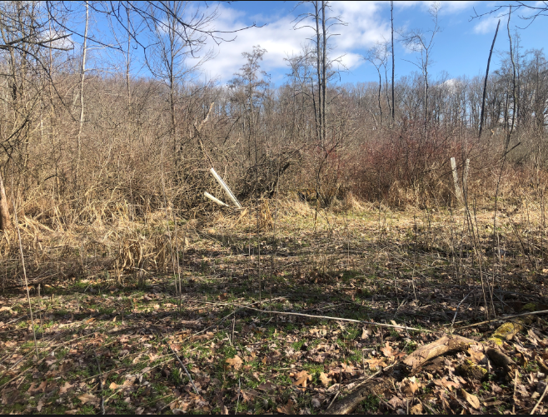
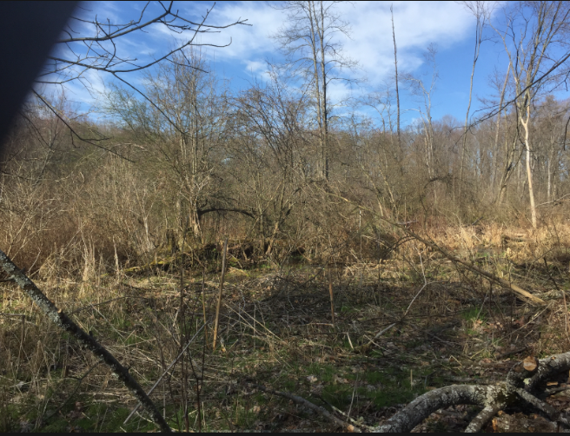
R4 April 5, 2017 R4 April 2, 2023

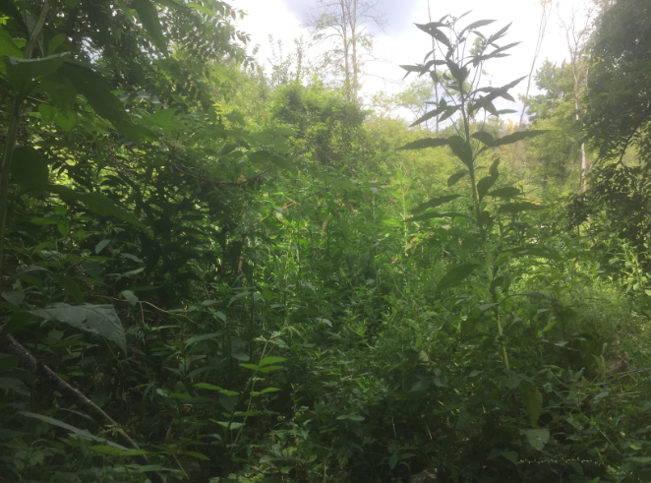
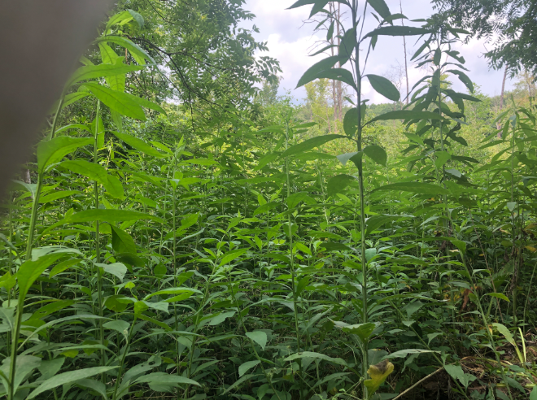
R4 August 10, 2017 August 2, 2023

